Ideation Phase
Define the Problem Statements

Date | 28 September 2026
Team ID | SWTID-2026-3101
Project Name | BlogNestAPI
Maximum Marks | 2 Marks

Customer Problem Statement :
Bloggers and content creators need a simple and reliable way to create, manage, update, and organize their blog posts because managing content through complicated or unorganized systems can be time-consuming and frustrating. They want to easily publish their ideas, edit their content when needed, access their posts whenever they want, and keep their information organized and secure. BlogNest aims to address this problem by providing users with a convenient blogging experience where they can manage their content efficiently and focus more on creating and sharing valuable ideas.

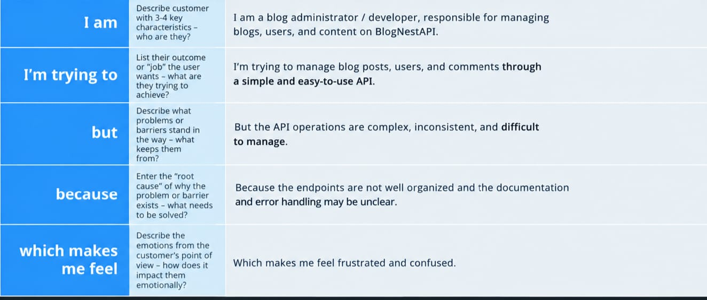

Problem Statement Example:
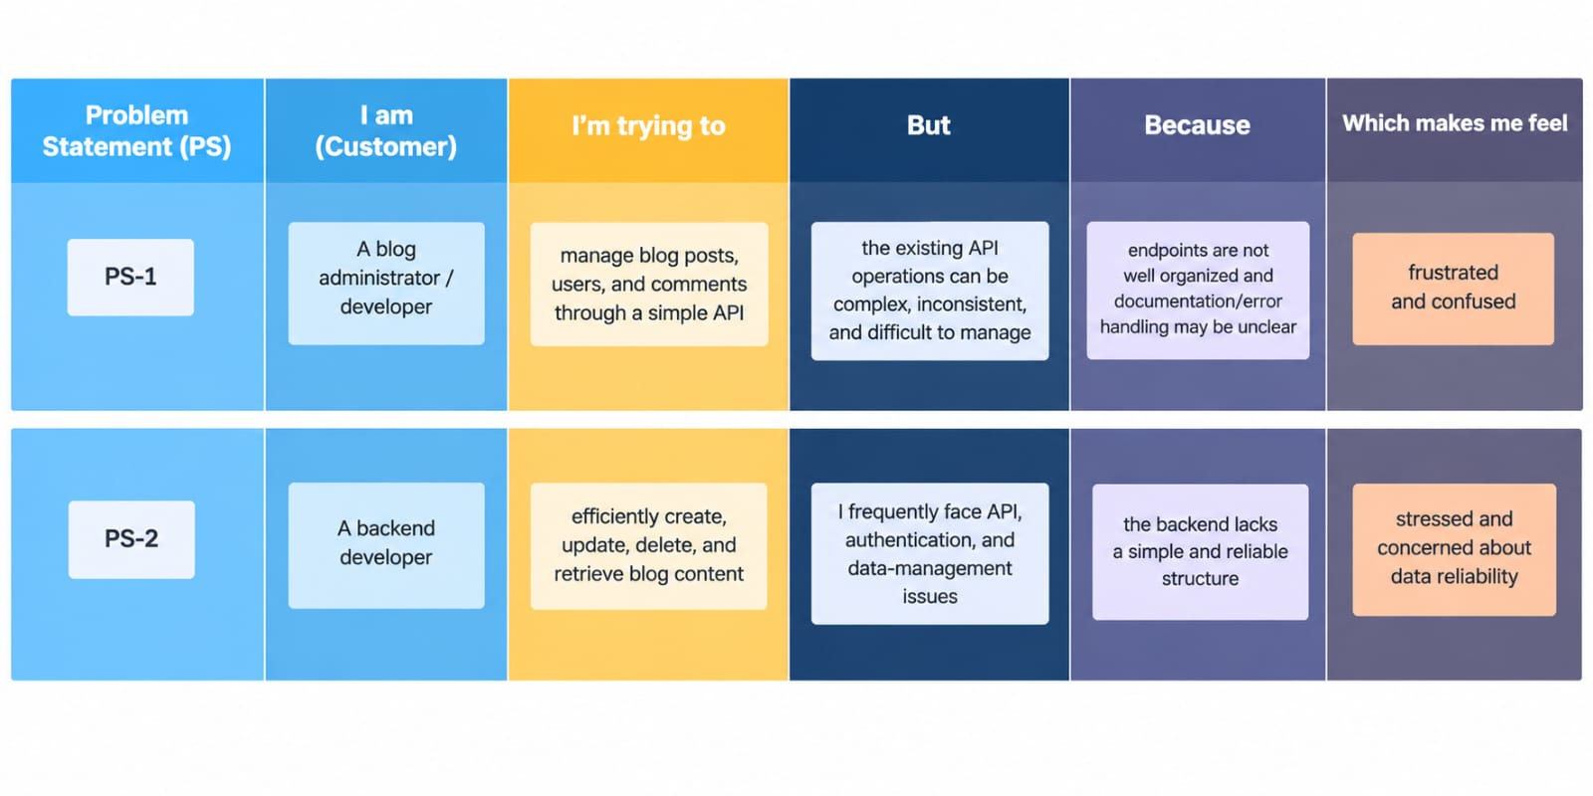
Problem Statement (PS) | I am (Customer) | I’m trying to | But | Because | Which makes me feel
PS-1 | A blog administrator | Manage blog posts, users, and comments through a simple API. | The API operations are complex, inconsistent, and difficult to manage. | Endpoints are not well organized and the documentation and error handling may be unclear. | Frustrated and confused.
PS-2 | A backend developer | Create, update, delete, and retrieve blog content efficiently. | API responses, authentication and data management can cause error’s and require extra debugging. | The backend lacks a simple, reliable. And well structured API design. | Stressed and concerned about data reliability.

